Classify Cassava Leaf Diseases Using an Artificial Neural Network (ANN)

1. Dataset Overview
Dataset is organized as follows:
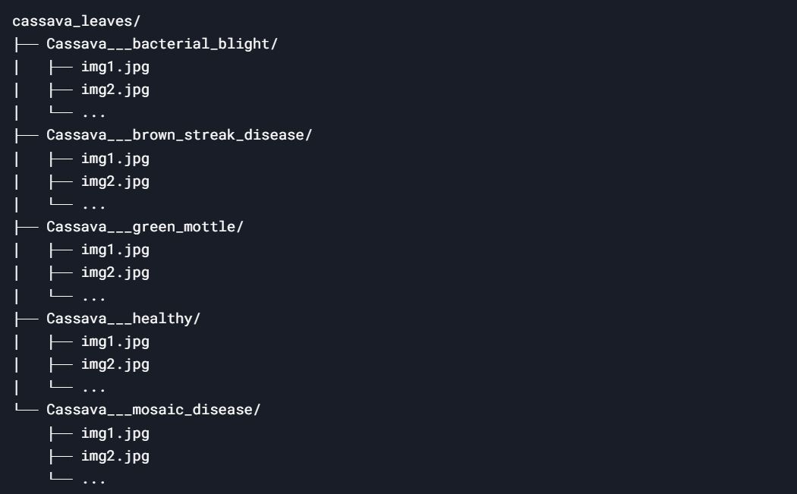
- Each folder represents a class (e.g., Cassava___healthy, Cassava___bacterial_blight, etc.).
- Each folder contains 1000 images of leaves corresponding to that class.

2. How the Code Works
Step 1: Load and Preprocess the Dataset
The dataset is loaded and preprocessed using ImageDataGenerator from TensorFlow/Keras. Here's how it works:
- ImageDataGenerator:
  - This tool helps in loading images from folders, resizing them, normalizing pixel values, and splitting the dataset into training and validation sets.
  - Key parameters:
    - rescale=1./255: Normalizes pixel values to the range [0, 1].
    - validation_split=0.2: Splits the dataset into 80% training and 20% validation.
- flow_from_directory:
  - This method reads images from the folder structure and assigns labels based on the subfolder names.
  - Key parameters:
    - target_size=(150, 150): Resizes all images to 150x150 pixels.
    - class_mode='categorical': Converts labels into one-hot encoded vectors (e.g., [1, 0, 0, 0, 0] for Cassava___bacterial_blight).
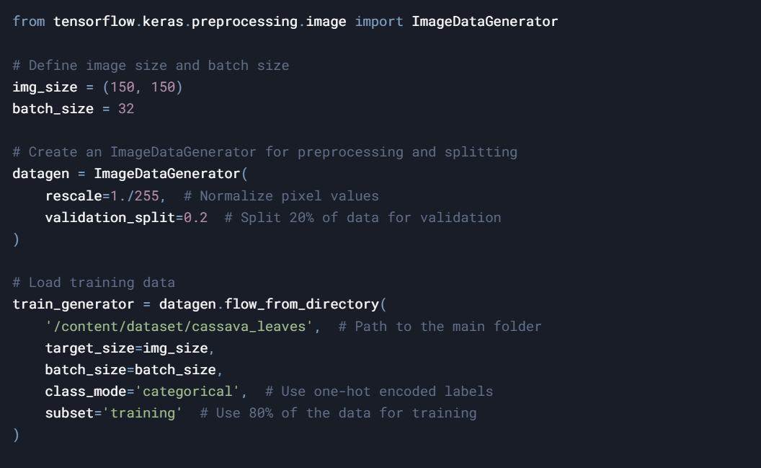
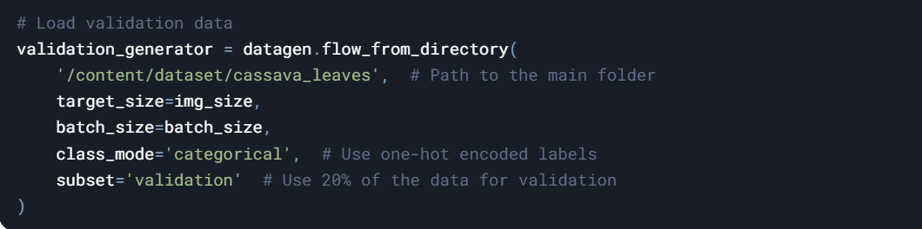

Output:
  - train_generator and validation_generator provide batches of images and their corresponding one-hot encoded labels.
  - For example:
    - Images shape: (32, 150, 150, 3) (32 images of size 150x150 with 3 color channels).
    - Labels shape: (32, 5) (32 one-hot encoded vectors for 5 classes).

Step 2: Build the ANN Model
The Artificial Neural Network (ANN) is a simple feedforward neural network. Here's how it works:
- Input Layer:
  - The input shape is (150, 150, 3), which corresponds to the size of the images (150x150 pixels with 3 color channels).
  - The Flatten layer converts the 3D image data into a 1D vector (e.g., 150 * 150 * 3 = 67,500 values).
- Hidden Layers:
  - Two fully connected (Dense) layers with ReLU activation are used to learn patterns in the data.
  - The first hidden layer has 128 neurons, and the second has 64 neurons.
- Output Layer:
  - The output layer has 5 neurons (one for each class) and uses softmax activation to produce a probability distribution over the 5 classes.
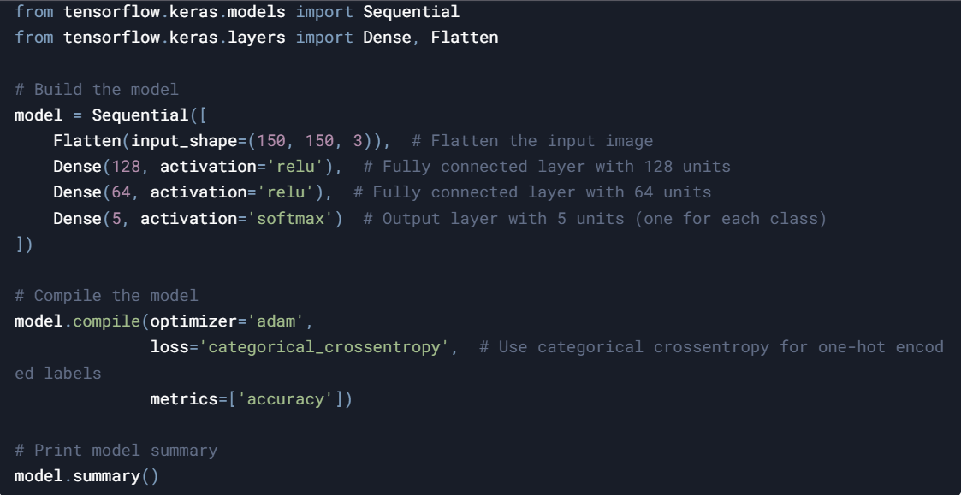

Output:
- The model summary shows the architecture and the number of parameters

Step 3: Train the Model
The model is trained using the fit method. Here's how it works:
- Training:
  - The model processes batches of images and labels from the train_generator.
  - It adjusts its weights using backpropagation to minimize the categorical_crossentropy loss.
- Validation:
  - After each epoch, the model evaluates its performance on the validation set (validation_generator).
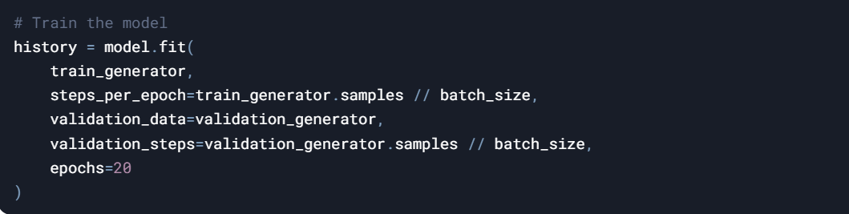

Output:
  - The training process prints the loss and accuracy for each epoch.

Step 4: Evaluate the Model
After training, you can evaluate the model's performance on the validation set and test it on new images.
- Evaluate on Validation Set:
  - Use the model.evaluate() function to calculate the accuracy of the model on the validation set.
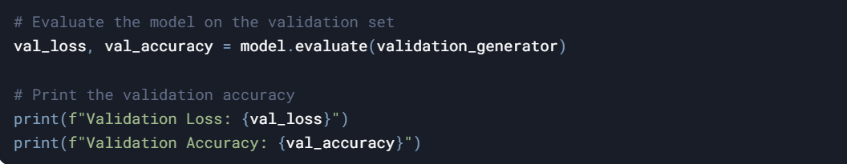
- Output:
  - The validation accuracy is printed as a percentage (e.g., 0.85 means 85% accuracy).
- Test on a New Image:
  - Load a new image, preprocess it, and use the model to predict its class.
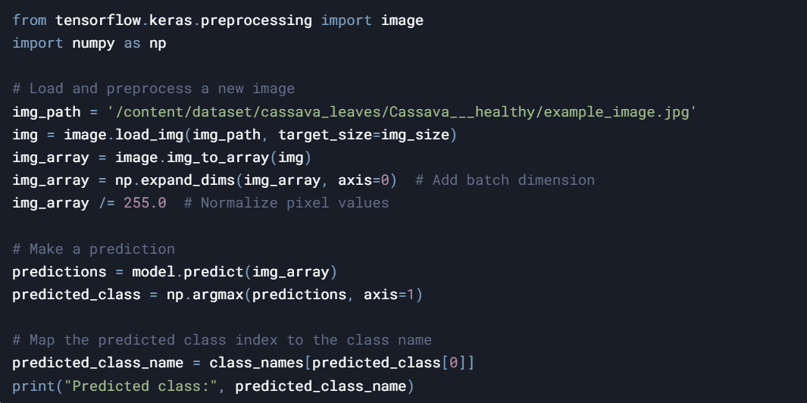

3. How the ANN Learns
- Input Data:
  - The images are flattened into 1D vectors and fed into the network.
- Forward Pass:
  - The input data passes through the hidden layers, where weights and biases are applied, and activation functions (ReLU) introduce non-linearity.
- Loss Calculation:
  - The categorical_crossentropy loss compares the predicted probabilities (output of softmax) with the true one-hot encoded labels.
- Backpropagation:
  - The model adjusts its weights using gradient descent to minimize the loss.
- Validation:
  - The model's performance is evaluated on unseen data (validation set) to ensure it generalizes well.

4. How It Knows Healthy vs Diseased Leaves
- The model learns to distinguish between healthy and diseased leaves by analyzing patterns in the pixel values of the images.
- During training:
  - It sees many examples of healthy leaves (from the Cassava___healthy folder) and learns their features.
  - It also sees examples of diseased leaves (from the other folders) and learns to differentiate them based on their unique features.
- The softmax output layer provides probabilities for each class, allowing the model to predict the most likely class for a given image.

5. Summary
- The dataset is loaded and preprocessed using ImageDataGenerator.
- The ANN learns to classify images by analyzing pixel patterns and adjusting its weights during training.
- The model distinguishes between healthy and diseased leaves by learning from labeled examples in the dataset.
- The accuracy of the model can be evaluated using the model.evaluate() function on the validation set.

